Some Memories of My Father
Students Name
Institutional Affiliation
Due Date

Some Memories of My Father
By Dean Bakopoulos
I was sixteen years old when my father went to the moon and it was the last time I saw him. This is the only remaining fact about my father as well as his memories. My father was big-hearted and a loving man who made low points that could last for several weeks. There are other times when my father seemed demoralized and perplexed as a person coming from a deep sleep troubled by sorrowful nightmares. I tried to remember any extended moments with my father but got none: no long trips, no extended talks with him giving me advice, and no fishing. My father was gone forever but his memories have somehow remained unclear to me.
I sat on my bed and began to recall some of his memories. I missed a lot of things about my father including how he used to prepare cheese sandwiches. Most of the nights, my father went to the fridge and picked two pieces of Wonder bread and two pieces of American cheese, and prepared a sandwich. His procedure for making sandwiches resembled a surgical procedure but produced an excellent and smart sandwich. I missed his surgical-like procedures, I missed how he used to fold his newspaper, his breakfast, the slippers beside his bed, and the scent of his cigarette.
Although I missed my father so much, I generally missed all fathers. I could travel to nearby neighborhoods to watch fathers engaging in different activities including their engagement in golf swings and washing their cars. I missed their abnormal breathing as a result of excessive smoking. I also missed their smell of beer and coffee as well as their aftershave.
It was no more than a year since my father left but I recalled little about him and I had to write down the little memories in my diary in fear of forgetting them. The first memory is when I was three years old when I was sitting on the floor while my father smoked and perspired while swearing at a machine. At the age of four, I was collecting firewood with my father when a bee swirled near my head and landed on the log in my hand. I gave him the log and he used his pocketknife to press the bee into the wood which then falls off.
My next memory was when I was five years old. My dad and I were at a wedding in late hours when an ambulance carrying somebody who had a heart attack arrived. An adult poured beer on my head and I began crying. My father grabbed the adult by his neckcloth and threw him on the floor. When I was six years old my father stayed in the basement for three weeks. He spent his nights sleeping on the sofa, he never shaved, and never went to work. We could sometimes listen to him vomiting and my mother told me that he was sick. Other times he cried in very loud weeps. I was not permitted to go to the basement. My mother went to see him after I had slept and I could hear them yelling at each other making it hard for me to sleep. On one of the nights, I heard the collision of a crushed mirror being knocked. In the preceding morning, my father joined us for breakfast for the first time in the three weeks he stayed in the basement. He was clean, shaved, and he went back to work.
My next memory was when I was seven and my father disappeared in one weekend. My mother called the police and he was found hitchhiking. When I was eight years, my father broke the Good Friday fast by taking kielbasa and ham. He drank beer and eat pork. My mother yelled at him and tried to call the priest who never answered her calls. He offered me a piece of kielbasa which I took and my mother yelled at me to stop. My father left the house later and I was left with my mother. I stayed up in the late hours reciting the Rosary asking the Virgin Mary for forgiveness.
Another memory was when I was nine. My father declared that we had to relocate to Arizona but in the morning he changed his mind and we never relocated. When I was ten, my father confessed to my mother that he had kissed a woman at an office party. He went out for one week after which he came back with two big pizzas and a jar of root beer. When I was eleven, my father got a warrant for driving under the influence and my mother threatened to divorce him.
When I was twelve years, my father kept his beard and mustache and started to work in the yard. He stopped drinking for 6 months and bought a family ticket to the Detroit Orchestra. When I was thirteen, my father told me to be prepared for frustration. He said that our lives were going to turn to disappointment. When I was fourteen years old, my father and I went to Florida after the death of his uncle. We thought we were to inherit close to half-million but unfortunately, the uncle had spent his money on his wife. On our way back, father told me that was the disappointment he had told me earlier.
Those were the memories I could remember of my father. The memories included both happiness and displeasing moments. Time spent with my father engaging in some activities was always full of happiness. Other moments were full of sorrow, for example, the time he was sick and stayed in the basement for some weeks were very distressful moments.
Reflection
This is a story about some of the memories of my father. I was inspired to write the story by the love I had for my father. I therefore never wanted to forget all his memories. My father and I interacted a lot and we performed most of the activities together including collecting firewood. I wished that the reader could understand how I missed my father. I wished that my father could still be there with me to enjoy beautiful moments with him including his excellent sandwiches and appetizing breakfast.
My story has used more flashbacks to describe my earlier memories with my father. I have flashbacks of several memories with my father during my early childhood. My story is generally a flashback story because most of the events described in the story happened in the past. I have also used imagery as a fiction device in my story. This is because I have used a language that is building actual pictures in the reader’s mind. For example, my description of how my father used to prepare his sandwiches creates a real image in the reader’s mind. I also used similes in my story, for example, I directly compared my father’s feeling of confusion and broken to waking up from deep sleep troubled by sorrowful nightmares.
I decided to change the tense of the story because it includes past events that happened during my early childhood. I also changed the first and the ending paragraphs as advised by my professor and my classmates. I changed the first paragraph to include a little description of my father before writing down his memories. I also changed a few words and lines for easy understanding by the reader.

Image of how my father used to make sandwich
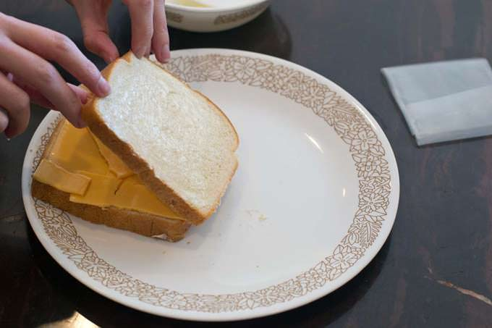
An image I took of fathers playing golf swings


